A

Project Report

is

Submitted to the completion of Epam-COE-DevOPS

Training Program

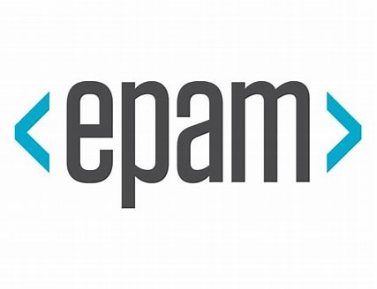

Submitted By:

Ms. Priyanka Bhardwaj

Junior Software Engineer-Epam Hyderabad

**Task –3 Configuration Management using Ansible (Roles)**

**Task --5 Building CI/CD pipeline to deploy new version of Application (Jenkins)**

----------> Created Three Instances on AWS running as Jenkins, Ansible and Docker Server

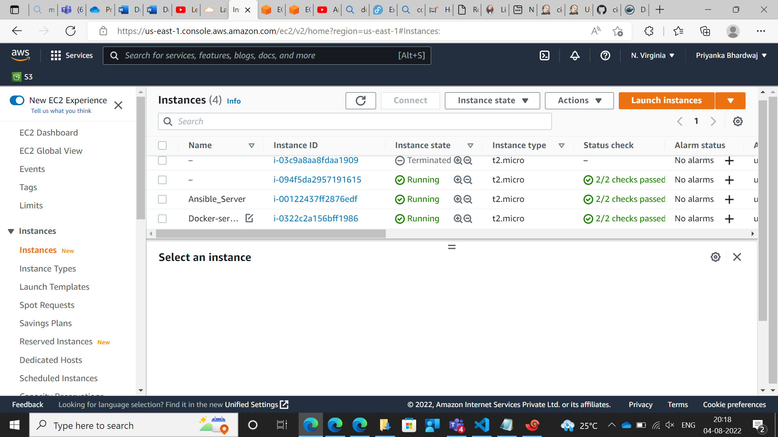

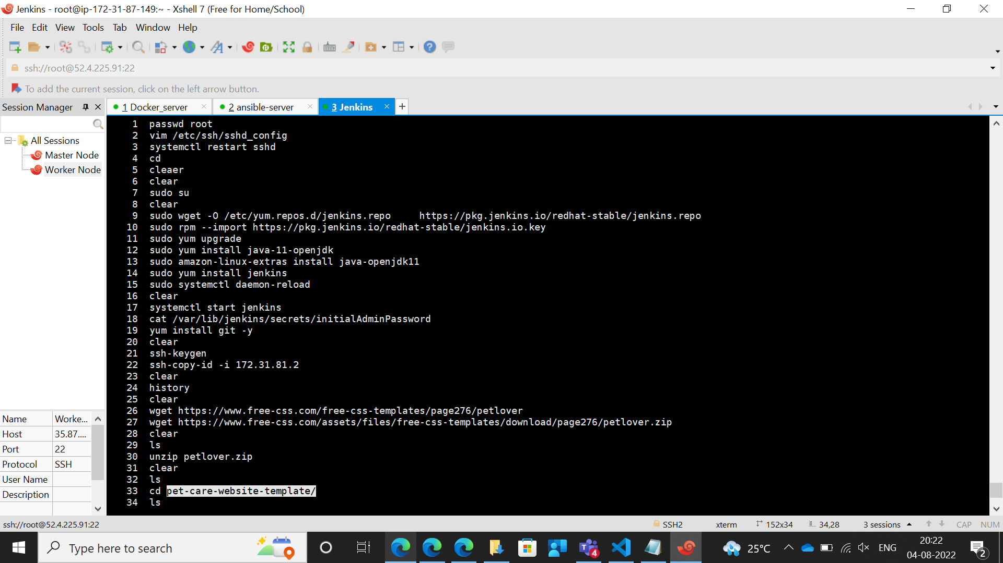

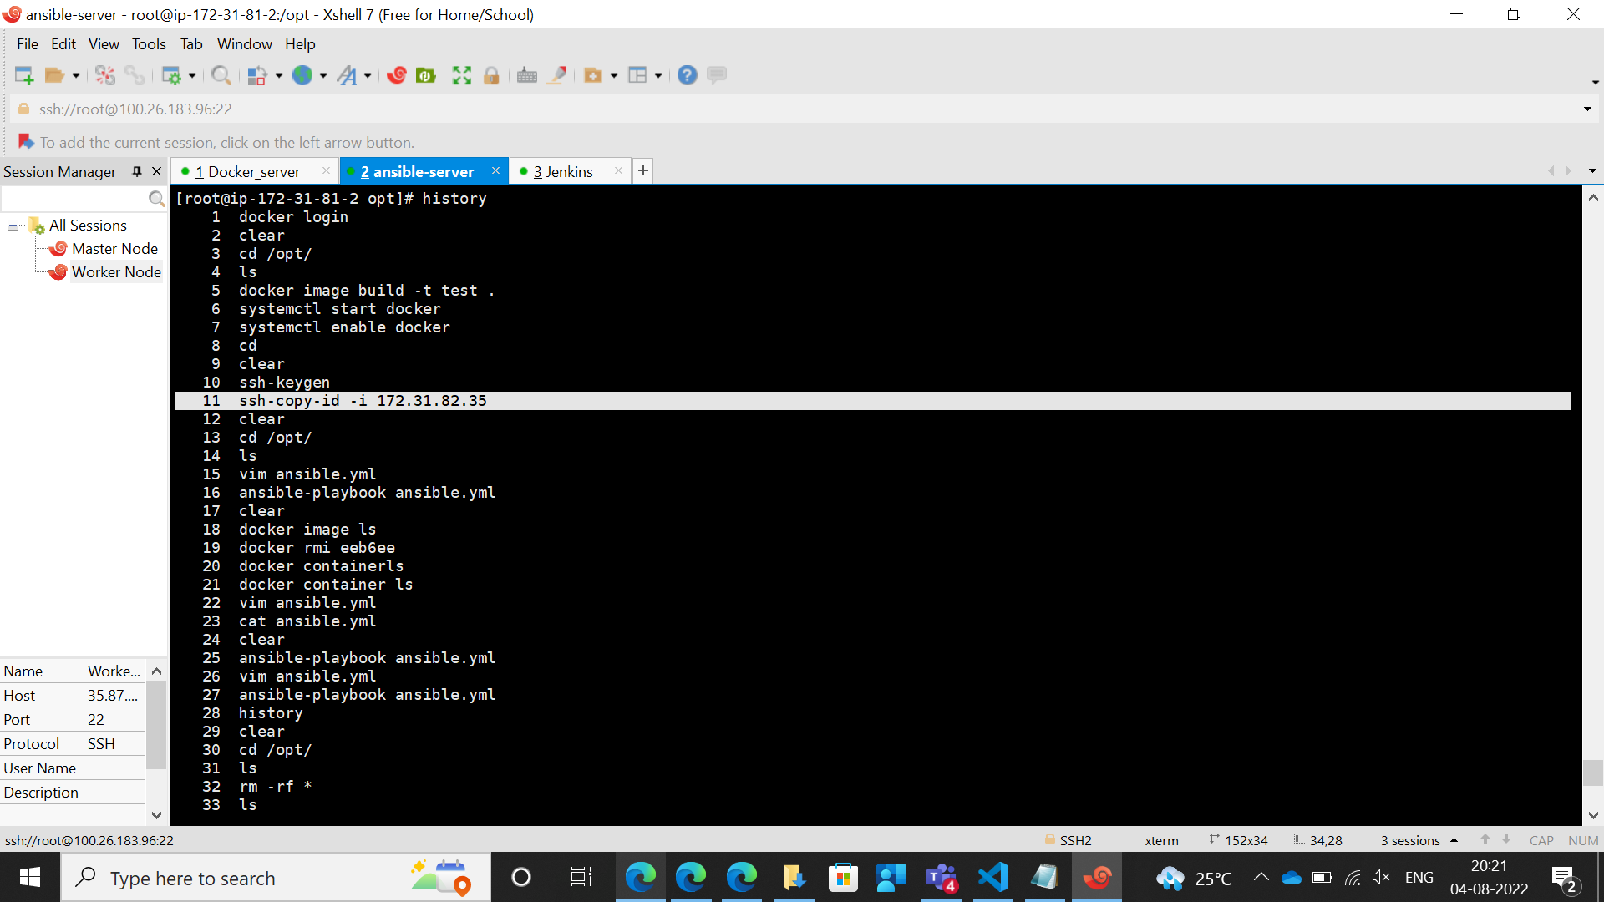

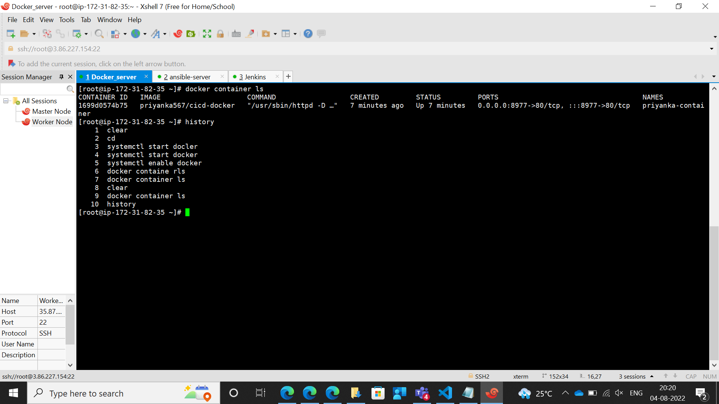

In the Project, given the github repository URL

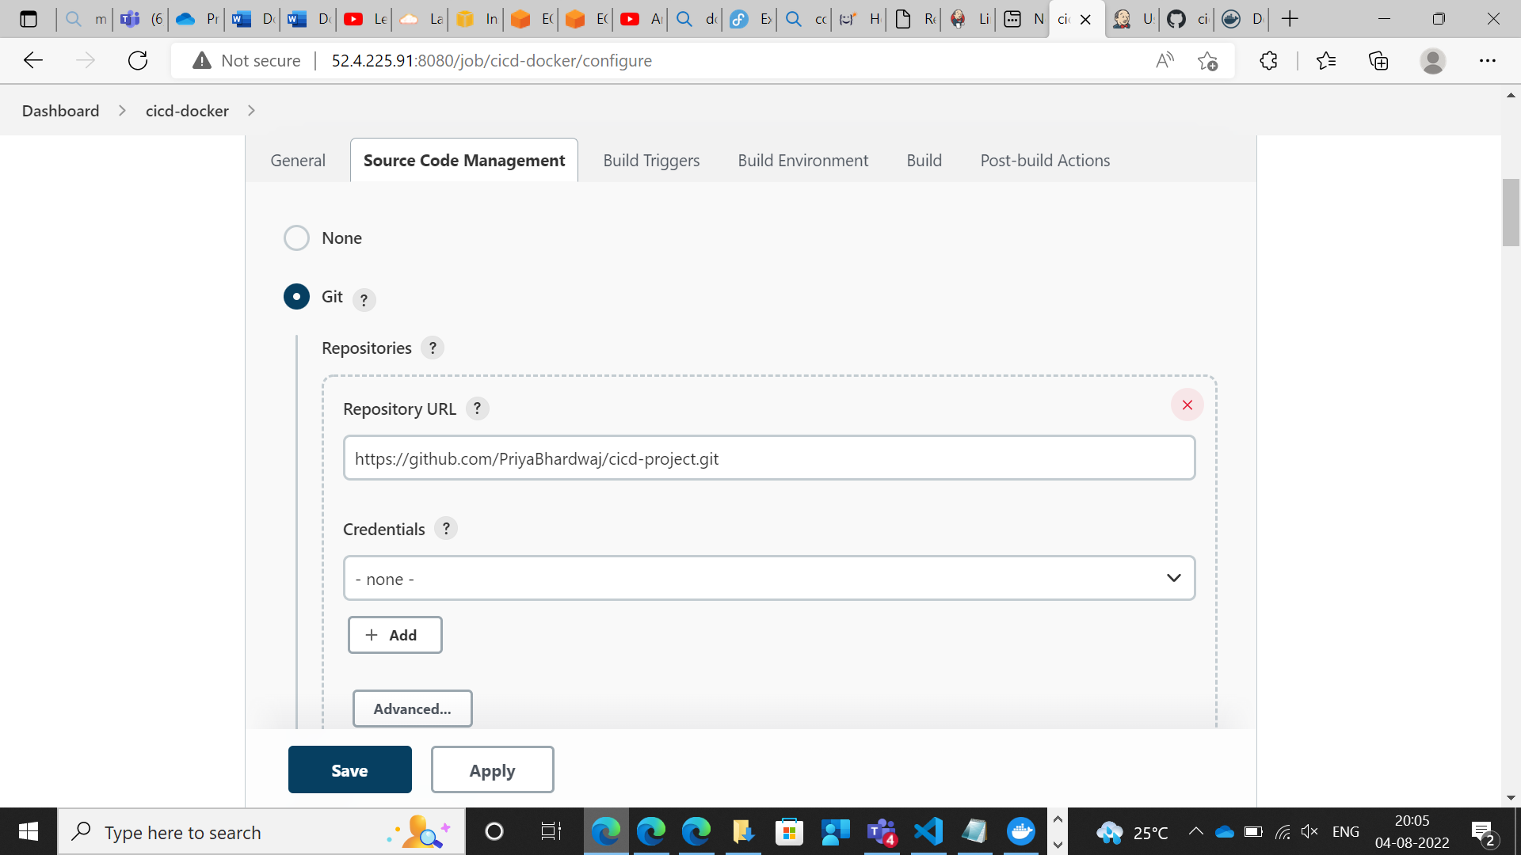

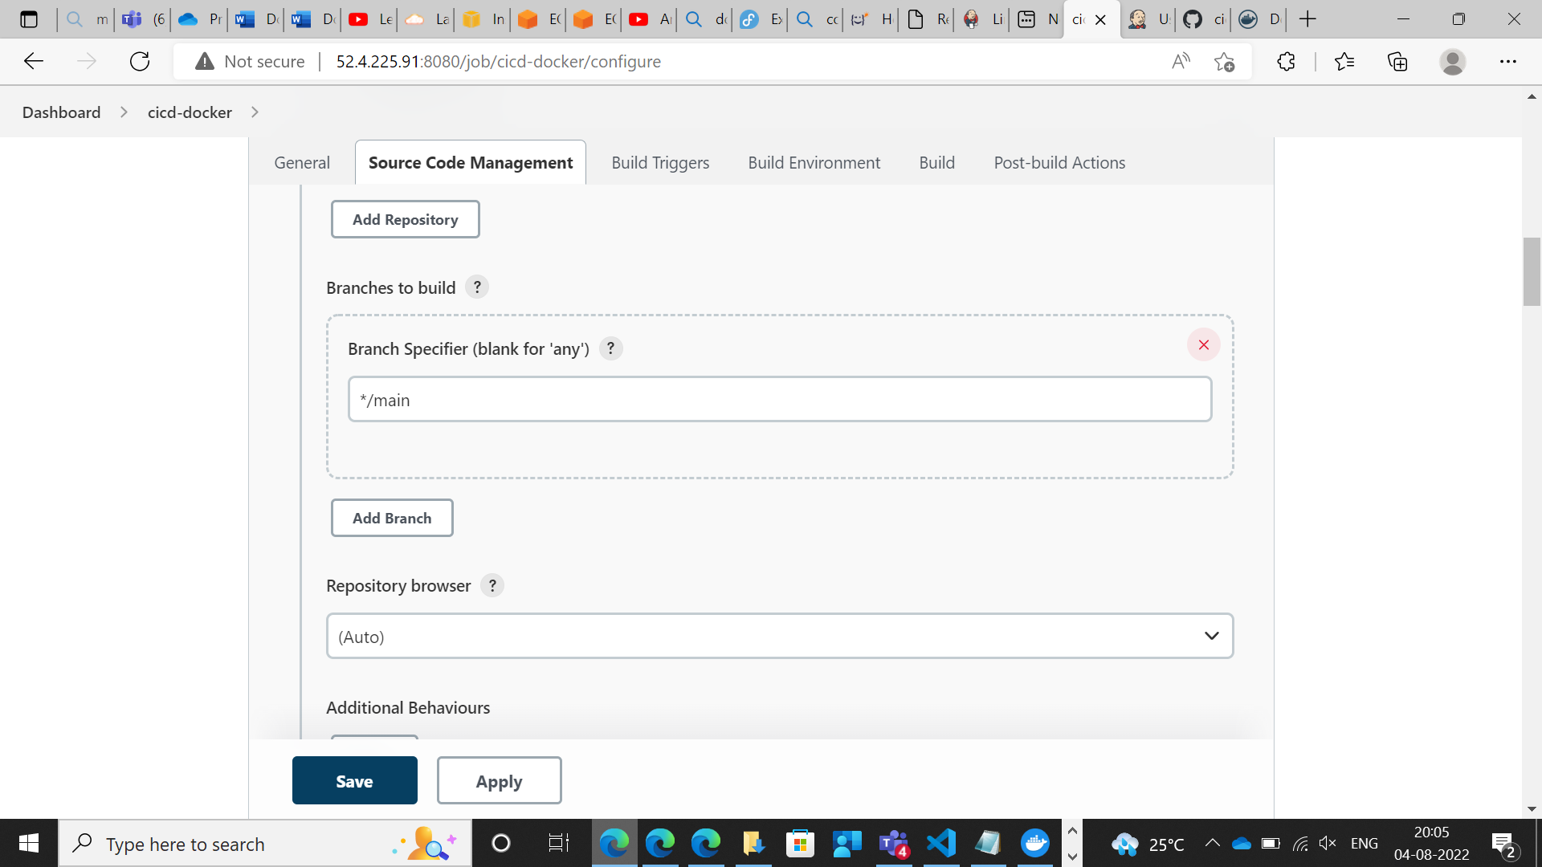

Trigger Build for the Automatic Build in Jenkins

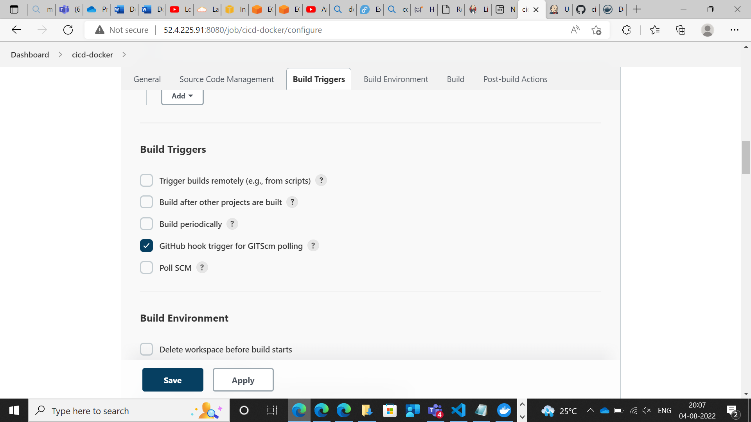

Connected Jenkins Server

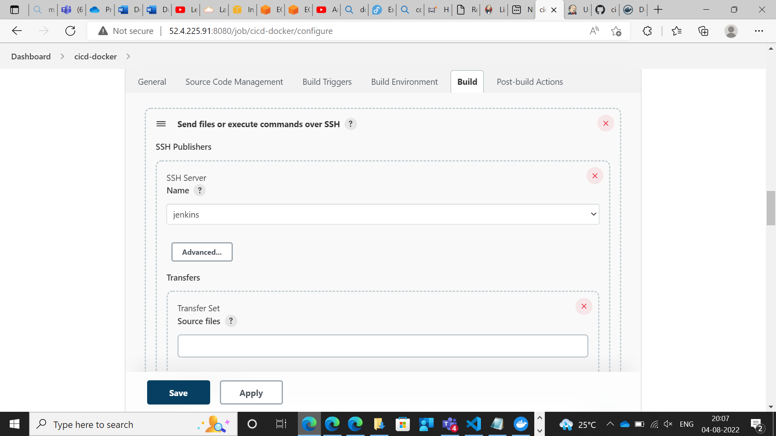

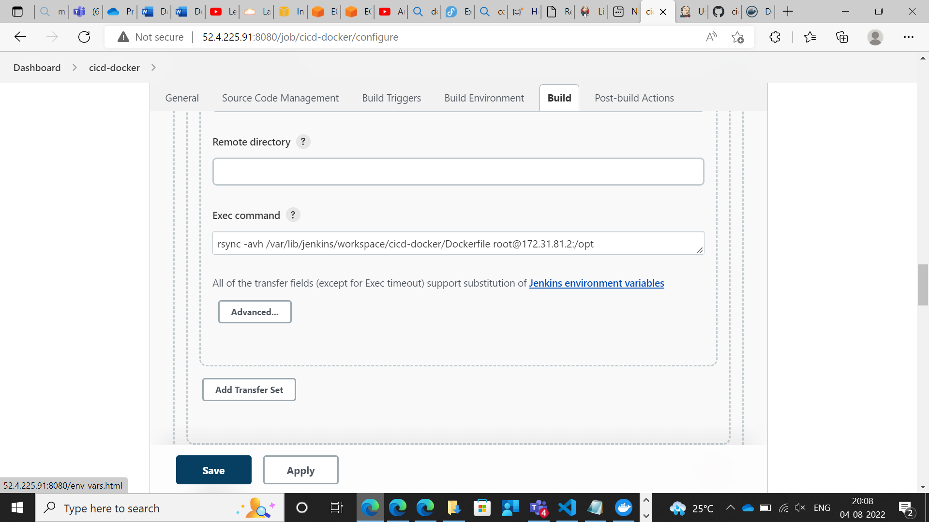

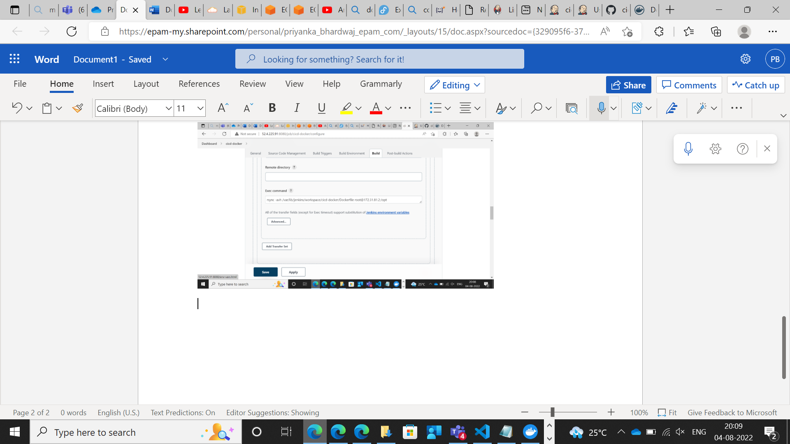

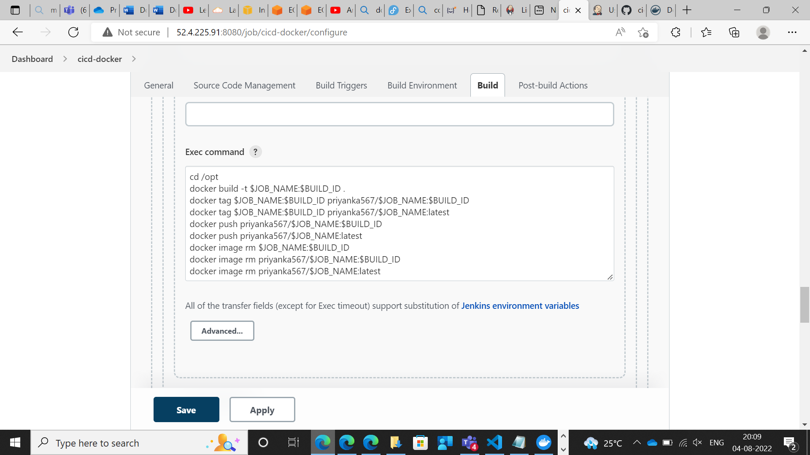

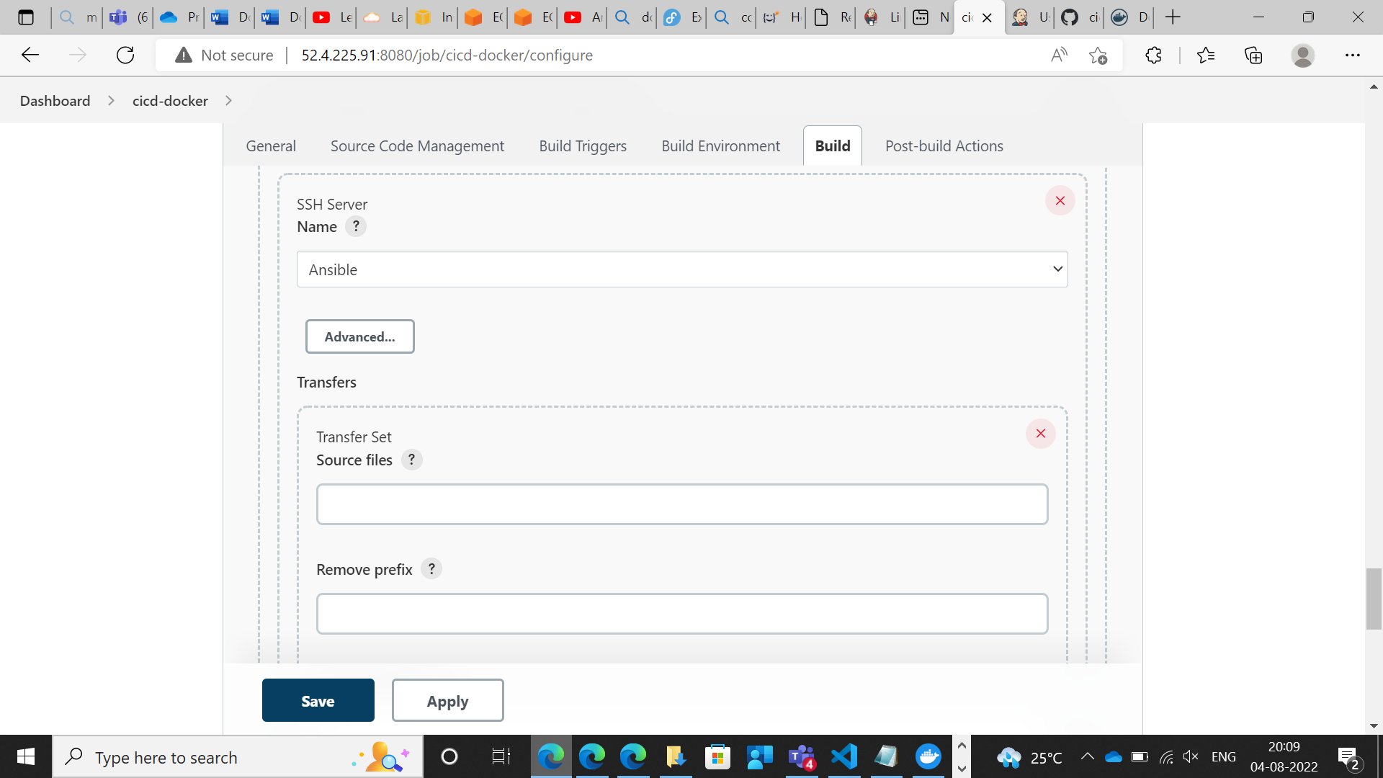

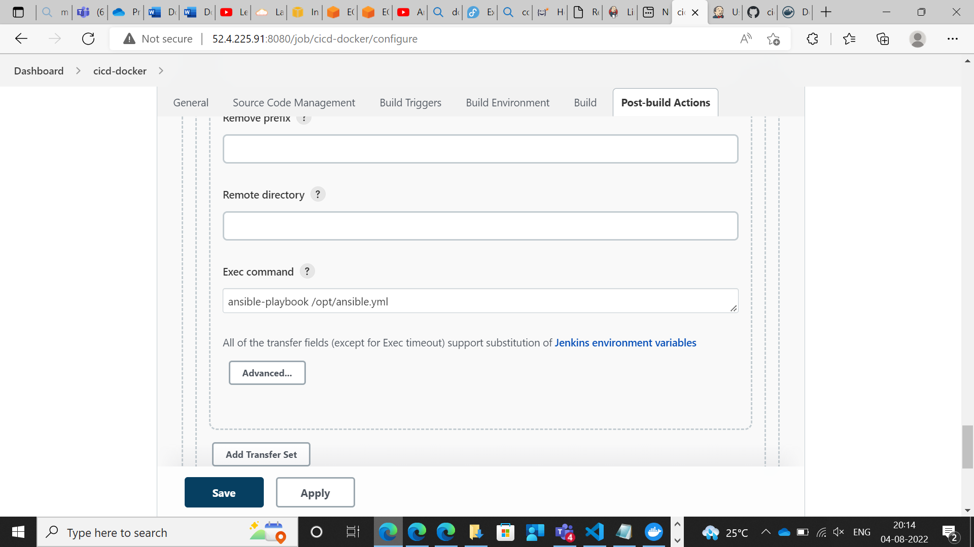

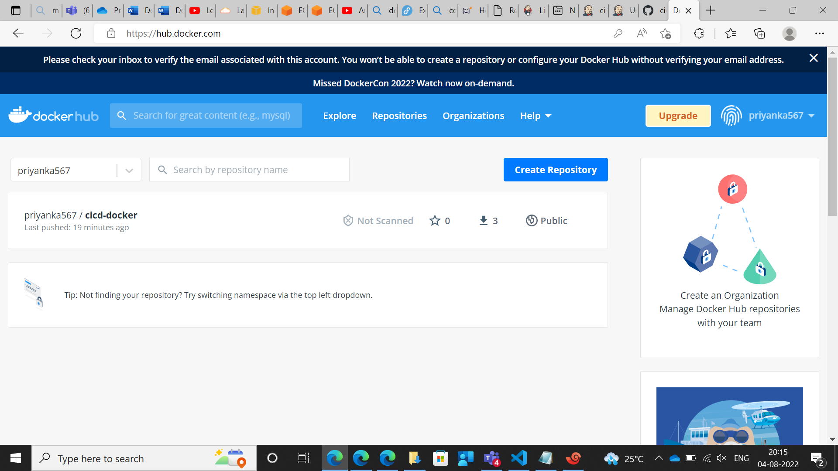

**Ansible YAML FILE**

- hosts: all

tasks:

- name: stop container

shell: docker container stop priyanka-container

- name: remove container

shell: docker container rm priyanka-container

- name: remove image

shell: docker rmi priyanka567/cicd-docker

- name: create container

shell: docker container run -itd --name priyanka-container -p 8977:80 priyanka567/cicd-docker

